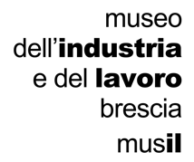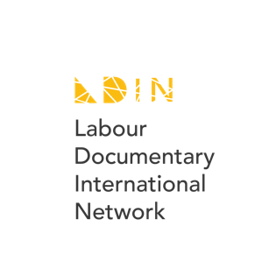

**LIDN - Labour International Documentary Network**

**General agreement**

1. **Acceptance.**

Signing this agreement I - in behalf of the institution/organization I represent - join the Labour International Documentary Network (LIDN).

1. **Concept and Structure.**

The LIDN is an international network devoted to the promotion of European documentary cinema on labour.

Concept is offering and promoting in universities and museums documentario films focused on about and work themes gathered and selected by film festivals,: in this way, contemporary, creative works promoted by cinema festivals will meet new audiences and, viceversa, professors and students (universities), as well as operators and visitors (museums), will discover updated, relevant contents.

The structure of the network include three types of subjects: (1) documentary festivals; (2) cinema universities, academies etc.; (3) museums or network of museums.

1. **Organization**

Each festival will propose titles (initially, in a number of three). Titles must be: feature and mid-lenght only; maximum two, minimum one produced in the same area where the festival is located; finished not later than 2020, not earlier than 2016.

The Network's selection commitee, composed by representatives of each partner, will define the group of works to be promoted on an annual basis.

Each partner will organize at least one event (screening etc.) per year officially marked as LIDN. These events will compose the LIDN annual program.

Each partner will finance the work of its representative and its own activities in the context of LIDN (screenings, meetings with authors etc.).

Coordinating role (secretary, website etc.) will be played by Mus**il** – museum of industry and labour of Brescia (Italy)

**(For Cinema Festivals)** …

As a partner of LIDN +++++, the festival I represent names ++++ as the contact person and representative regarding LIDN activities. She will be our representative member in the international LIDN selection committee unless any further communication about a different arrangement will be sent to Musil. I accept and agree that every festival will select and submit to the selection committee three titles (feature and mid-lenght only, maximum two, minimum one produced in the same area where the festival is located and work, finished not later than 2020, not earlier than 2016) one of which will eventually be part of the LIDN final selection. Authors and rights holders of every film included in the three titles short lists will be supposed to be already informed about LIDN activities and open to accept the deals and agreements to be signed in order to take part in them. I accept and agree that every festival commits to organise, along the interested season, at least one event officially marked as LIDN, within or outside its main annual event; that every festival commits as well sending one representative to take part in a LIDN event organised by another LIDN partner. I accept and agree that all festivals are requested to identify local potential partners in their region of interest (universities, film schools, cultural and social foundations, museums, etc.), to get in touch and to probe and discuss their potential interest to get involved in the network.

**(For Universities)** As a partner of LIDN +++++, the department I represent names ++++ as the contact person and representative regarding LIDN activities within our staff. I Accept and agree that as a member of LIDN our department commits to organise and to promote at least one screening of the films included in the LIDN final selection, inviting - in presence either virtually - at least one author, specialist or professional to present and discuss the film. I accept and agree that any event linked with LIDN will be planned and organised cooperating with Mus**il** as the leading partner institution.

**(For Museums or network of museums)** As a partner of LIDN +++++, the museum I represent names ++++ as the contact person and representative regarding LIDN activities within our staff. I Accept and agree that as a member of LIDN our museum commits to organise and to promote at least one screening of the films included in the LIDN final selection, inviting - in presence either virtually - at least one author, specialist or professional to present and discuss the film. I accept and agree that any event linked with LIDN will be planned and organised cooperating with Mus**il** as the leading partner institution.